Name: Phong Tran
Class: CSCE 441

Ray Tracing

In this scene, there are:
- 2 planes: vertical in the back and horizontal in the front
- 4 spheres: red, green, purple, and gray
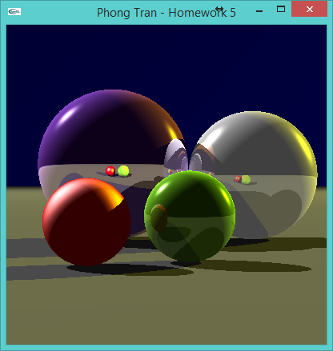
- 2 light sources: white light on the left and yellow light on the right.

Each light casts shadows on each sphere. Each sphere's shadows are visible on the plane as well as on other spheres. For example, the shadow cast by the green sphere onto the red sphere. Calculation of local light follows closely with formulas mentioned in slides of chapter 13 and 15. Each sphere and plane has different coefficients of ambient, diffuse, specular, specular exponents, and reflectance. They all contribute to the lighting, shadow, and reflection calculation. For example, red sphere doesn't reflect light and looks like plastic while the purple sphere reflects like a mirror. At the point where the purple sphere and the white sphere touch, multiple levels of reflection is demonstrated.

